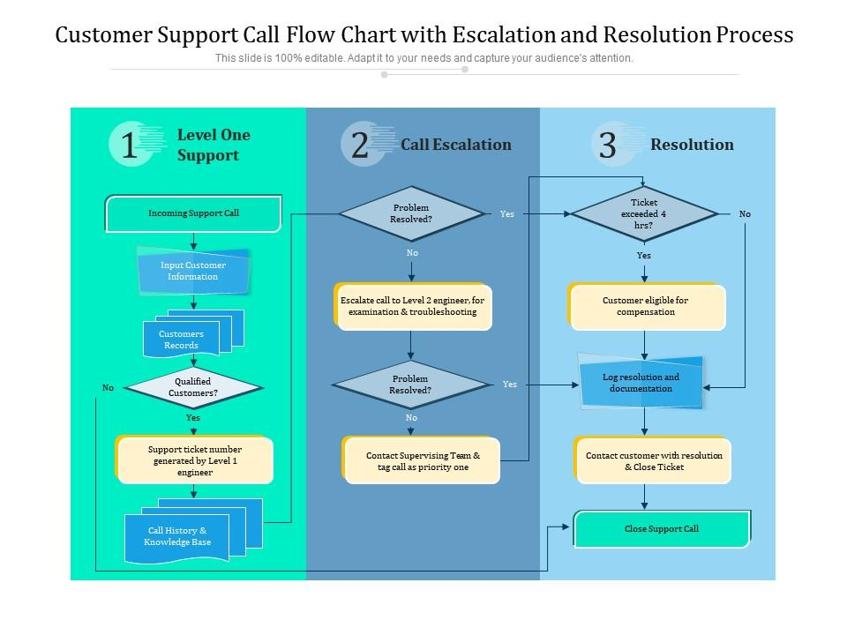

Reference list

Slideteam.net. (2024). *Customer support call flow chart with escalation and resolution process*. [online] Available at <https://www.slideteam.net/customer-support-call-flow-chart-with-escalation-and-resolution-process.html> [Accessed 3 Nov. 2024].